🚀 1. LAB: Cron Jobs (Scheduling Tasks)
Think of Cron as:
⏰ an automatic alarm clock for Linux
Instead of waking YOU up…
👉 it wakes up COMMANDS and SCRIPTS automatically.

🧠 This line:
* * * * * /home/kali/backup.sh
means:
👉 “Run the script backup.sh automatically again and again.”

🔍 Break it slowly
* * * * * /home/kali/backup.sh
Left side = TIME
Right side = WHAT TO RUN

⏰ The 5 stars mean TIME
* * * * *
│ │ │ │ │
│ │ │ │ └── Day of week
│ │ │ └──── Month
│ │ └────── Day of month
│ └──────── Hour
└────────── Minute
My Hungry Dog Makes Waffles
Minute → Hour → Day → Month → Weekday (0–59, 0–23, 1–31, 1–12, 0–7)

🧠 The second part
/home/kali/backup.sh
This is:
👉 the FULL PATH of your script
Linux needs full address like:
House number + street name

🎯 So COMPLETE meaning is:
Every minute,
x

🚀 Real-Life Example
Imagine:
You own a shop.
Every night at 10 PM:
👉 you want automatic backup.
Instead of manually typing:
./backup.sh
Cron does it automatically 😎

🧪 Example Script
#!/bin/bash
echo "Backup done at $(date)" >> backup.log
This means:
👉 save current date/time into file

📂 What happens with cron?
Every minute:
👉 Linux runs script
👉 Script writes into backup.log

🔍 Output example
Backup done at Mon Aug 18 10:00
Backup done at Mon Aug 18 10:01
Backup done at Mon Aug 18 10:02

🧠 Simple analogy
Real Life | Cron
Alarm clock | Cron
Alarm rings | Script runs
Daily routine | Scheduled task

🔥 Some useful timings
Every 5 minutes
*/5 * * * *

Every day at 10 PM
0 22 * * *

Every Sunday
0 9 * * 0

⚡ Important command
Open cron editor:
crontab -e
👉 This is where you add schedules.

🎤 Interview answer
“Cron is a Linux scheduler used to automate tasks at specific times or intervals.”

💡 Easiest way to remember
Cron = Automatic task runner in Linux

🎯 Goal
Automate a script to run every minute.

⚙️ Step 1: Create script
nano backup.sh
Paste:
#!/bin/bash
echo "Backup completed at $(date)" >> backup.log
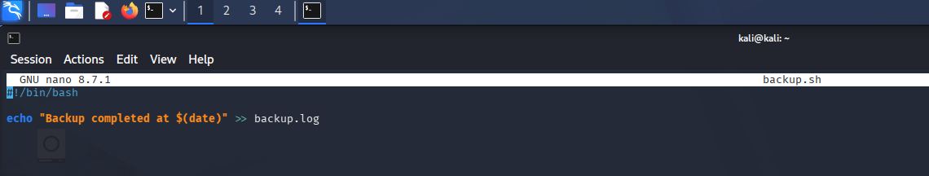

🔐 Step 2: Give permission
chmod +x backup.sh

⏰ Step 3: Open cron scheduler
crontab -e
Add:
* * * * * /home/kali/backup.sh
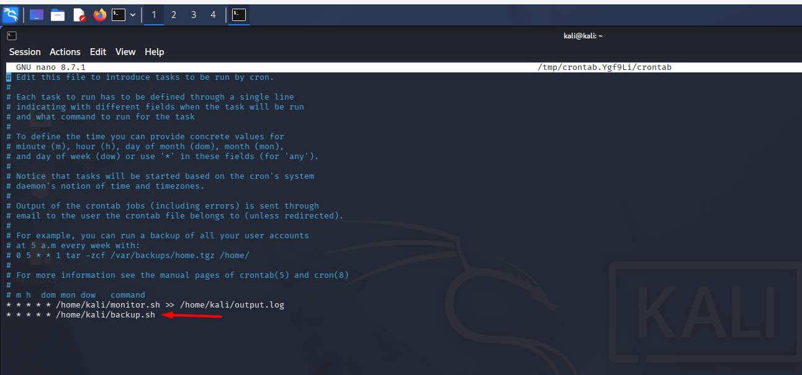

🔍 Step 4: Verify
cat backup.log
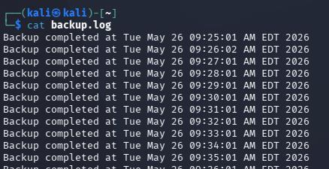

🧪 🔥 2. LAB: Firewall Basics (ufw)
🎯 Goal
Allow/block ports using firewall.

⚙️ Step 1: Check firewall status
sudo ufw status

✅ Step 2: Allow SSH
sudo ufw allow 22

🌐 Step 3: Allow web traffic
sudo ufw allow 80

❌ Step 4: Block FTP
sudo ufw deny 21

🚀 Step 5: Enable firewall
sudo ufw enable

🔍 Step 6: Verify rules
sudo ufw status numbered

🧪 💻 3. LAB: Virtual Servers
🎯 Goal
Understand virtual machine basics using VirtualBox.

⚙️ Step 1: Install VirtualBox
sudo apt install virtualbox -y

🖥️ Step 2: Create VM
- Open VirtualBox
- Click “New”
- Name: Ubuntu-Server
- RAM: 2GB
- Disk: 20GB

📀 Step 3: Attach ISO
- Settings → Storage
- Add Ubuntu ISO

▶️ Step 4: Start VM
Install Linux server.

🔍 Step 5: Check VM IP
ip a

🧪 📂 4. LAB: FTP (File Transfer)
🎯 Goal
Transfer files using FTP server.

⚙️ Step 1: Install FTP server
sudo apt install vsftpd -y

▶️ Step 2: Start service
sudo systemctl start vsftpd
sudo systemctl enable vsftpd

🔍 Step 3: Verify
systemctl status vsftpd

📁 Step 4: Create test file
echo "FTP Test" > file.txt

🌐 Step 5: Connect locally
ftp localhost
Login using your Linux username/password.

📤 Step 6: Upload file
Inside FTP:
put file.txt

🧪 🐚 5. LAB: Shell Scripting Fundamentals
🎯 Goal
Learn variables, input, conditions.

⚙️ Step 1: Create script
nano basic.sh
Paste:
#!/bin/bash
echo "Enter your name:"
read name
echo "Hello $name"
if [ "$name" == "Anamika" ]
then
echo "🔥 Welcome DevOps Learner!"
else
echo "👋 Keep learning!"
fi

▶️ Step 2: Run
chmod +x basic.sh
./basic.sh

🧪 💽 6. LAB: Disk Partitioning Basics
🎯 Goal
View disks and partitions safely.
⚠️ Do NOT modify real partitions unless using VM.

🔍 Step 1: View disks
lsblk

📊 Step 2: View partition table
sudo fdisk -l

💾 Step 3: Create virtual disk file
dd if=/dev/zero of=disk.img bs=1M count=100
👉 Creates 100MB fake disk

🔗 Step 4: Attach loop device
sudo losetup -fP disk.img

🔍 Step 5: Find loop device
losetup -a
Example:
/dev/loop0

⚙️ Step 6: Partition fake disk
sudo fdisk /dev/loop0
Inside fdisk:
n → new partition
p → primary
w → write changes

🔍 Step 7: Verify
lsblk

🎤 Interview-ready skills from these labs
✅ Automation using cron
✅ Firewall configuration
✅ VM/server management
✅ File transfer using FTP
✅ Shell scripting basics
✅ Disk & partition management

